**Jenga**

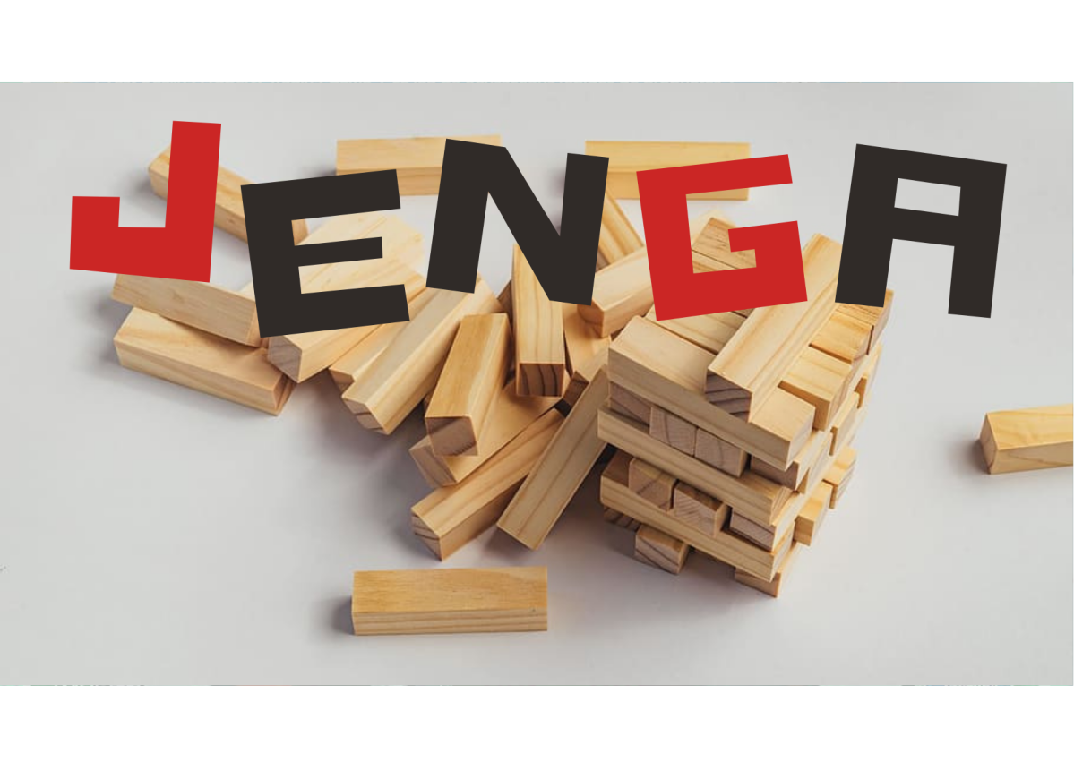

**Description:** A fun and challenging game that tests your dexterity and strategic thinking.

**How to Play:** Players take turns removing one block at a time from a tower and balancing it on top until the tower collapses.

**Location:** Indoor

**Things Needed:** Jenga blocks

**Number of Players:** 2 or more